# How to Update the Documentation

**Consider the Use Case**:

* You have a test suite with three tests
  + Script Automation Test 1
  + Script Automation Test 2
  + Script Automation Test 3

* You have executed the script and it has produced documentation

* Open a documentation file and you will see the following

## Tester Link Update:

* This is the environment being tested, copy & paste the URL
  + <https://bkc-pp.guidingcare.com/R1/Portal/Account/Login>

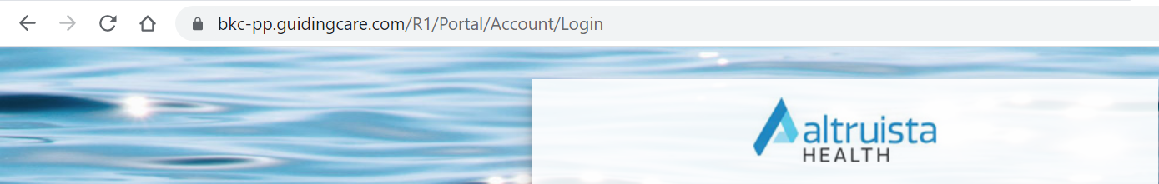

## Additional Information Update:

* If the test is **PASSED**
  + **TEST STATUS: COMPLETE/PASSED**
* Visual Aid:

---------------------------------------------------------------------------------------------------------------------

* If the test is **NOT APPLICABLE**
  + **TEST STATUS: NOT APPLICABLE**
* Visual Aid:

---------------------------------------------------------------------------------------------------------------------

* If the test is **FAILED**
  + **TEST STATUS: FAILED**
* Visual Aid:

## Test Case Link(s) Update:

* Click **Insert**

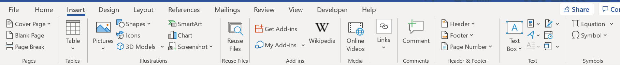

* Click **Links**

* Click **Link**

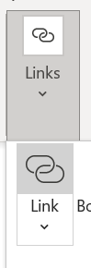

* **Text to display** = ADO_UNIQ_ID
  + **425609** in this case
* **Address** = ADO_Test_Case_URL
  + Double click the test case

* + Left click the hyperlink



* + Click **Open link in new tab**

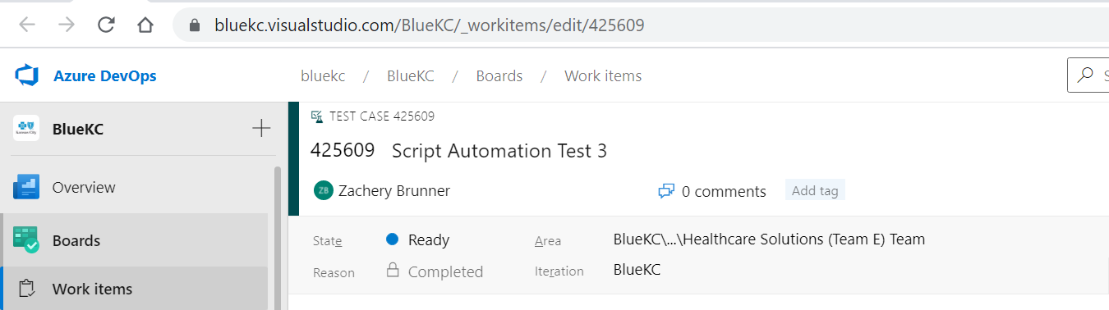

* + Copy URL



* Final product should look like this

* Click **OK**

[425609](https://bluekc.visualstudio.com/BlueKC/_workitems/edit/425609)

## Picture Supplement

* Testers are still required to supplement the documentation with screenshots